

|  |  |
| --- | --- |
| Course Number and Name:  ME 747 | |
| Semester and Year:  Fall 2017 | Name of Lab Instructor:  Alireza Ebadi |
| Lab Section and Meeting Time:  Section 2B, Tuesday 2-5 pm | Report Type:  Internal Group Report |
| Title of Experiment:  Velocity and Position Sensors: LVT and LVDT Characterization, Parameter Identification | |
| Date Experiment Performed:  10/17/17 | Date Report Submitted:  10/31/17 |
| Names of Group Members:  Zhangxi Feng  Simon Popecki  Reilly Webb | Grader's Comments: |
| Grade: |

Table of Contents

Objectives 3

Executive Summary 4

Theory and Experimental Methods 5

Results and Discussion 12

Conclusions 20

References 21

Appendices 22

List of Figures

Figure 1: RC Circuit 8

Figure 2: Lab Instrumentation Panel 8

Figure 3: RLC Circuit 9

Figure 4: Function Generator 9

Figure 5: DAQ Device 10

Figure 6: Comparing Theoretical and Experimental Step Response 12

Figure 7: 1st Order Frequency Response Bode Plot 13

Figure 8: Simulated Step Response of the RLC Circuit 14

Figure 9: 2nd Order System Frequency Response Bode Plot 16

Figure 10: Experimental and Theoretical Labview Results for the 1st order system 17

Figure 11: Experimental and Theoretical LabView results for the 2nd order system 18

List of Tables

Table 1: Calculating Tau and Capacitance from step response 11

Table 2: 1st Order Frequency Response Data 12

Table 3: Frequency Response Data of the 2nd Order System 15

# Objectives

The characteristics of a mass-spring-damper system were determined through the use of a linear velocity transducer (LVT) that produces a voltage proportional to the velocity of a magnetic core. Next, the properties of a linear variable differential transformer were investigated by calibration through weights and beam deflection. The effects of modulation and filtering were also observed. Experimental frequency response of the system was then determined using Lab View Signal Express.

# Executive Summary

# Theory and Experimental Methods

**Theory**

1. Linear Velocity Transducer

$$m=74.9 g$$

$$ζ=0.1130$$

$$T=0.0813\frac{s}{cyc}, ω_{d}=\frac{2π}{T}=77.3188\frac{rad}{s}$$

$$ω_{n}=\frac{ω_{d}}{\sqrt{1-ζ^{2}}}=\frac{2π}{T\sqrt{1-ζ^{2}}}=77.8171\frac{rad}{s}$$

$$k=ω_{n}^{2}*m=453.5567\frac{kg}{s^{2}}=453.5657\frac{N}{m}=31.1\frac{lb_{f}}{ft}=2.588\frac{lb_{f}}{in}$$

**The average force of impact** when the shaft hits the foam would be equal to the damping force of the foam, which is relative to its damping coefficient:

$$B=2*ζ*\frac{k}{ω_{n}}=1.3171\frac{N}{m/s}=0.09025\frac{lb_{f}}{ft/s}$$

Using damping force formula:

$$F_{avg}=B*v_{i}$$

Where $v_{i}$ is the velocity of the mass upon impact with the foam, using the first three minimum peaks in Figure 1 (since the first three falls are estimated to be free falls):

$$v_{i}=[-29.59, -16.03, -8.46]$$

Which gives an average force:

* 1. And 2.2 LVDT System Characteristics and Calibration

The range of linearity of the LVDT can be found with the coefficient of determination

$$R^{2}=1-\frac{\sum{{\left(y-y_{fit}\right)}^{2}}}{\sum{{\left(x-\overline{x}\right)}^{2}}}$$

Both calibrations resulted in an $R^{2}$ of about 1, meaning that they are very linear.

Spring constant, k, was found through Hook’s law

$$k=\frac{F}{x}=166.5 lbf/in$$

In this case, this was determined through finding the slope of the fitted line to the weight to displacement calibration data.

Sensitivity was found in a similar fashion, using the slope of the voltage to deflection line

$$Sensitivity=\frac{V}{x}=2.96 V/in$$

The damping ratio can then be found from the raw data using the log decrement method on any two successive peaks

$$ζ=\frac{1}{\sqrt{1+(\frac{2π}{δ})^{2}}}=.0050 where δ=\frac{1}{n} ln⁡(\frac{x\left(t\right)}{x\left(t+nT\right)})$$

where $x(t)$ is the amplitude at time $t$, $T$ is the period, and $n$ is the number of positive successive peaks. The damped and undamped natural frequency can then be found as follows

$$ω_{d}=\frac{2π}{T}=191.500 rad/s$$

$$ω_{n}=\frac{2π}{T\sqrt{1-ζ^{2}}}=191.533 rad/s$$

Effective mass could then be calculated

$$M_{eff}=\frac{-k}{ω_{n}^{2}}=0.0045 kg$$

2.3 LVDT Frequency Response

The break frequencies were found by extrapolating a linear fit for the horizontal line for usable bandwidth in the magnitude plot. Then the intersection points with the sloped filtered magnitude lines were found such that the error with the actual curve is about 3 dB. The frequencies at these two points are the break frequencies. See Figure #####



Figure : 1st Break Frequency Approximation. The larger time division data was used.



Figure : 2nd Break Frequency Approximation. The smaller time division data was used.

$$f_{b1}=308.3 Hz , f_{b2}=47485 Hz$$

The LVDT system follows the following transfer function

$$\frac{E_{o}(jω)}{E_{i}(jω)}=\frac{2R_{m}K_{m}xs/(R_{m}+2R_{s})R_{p}}{(\frac{L_{p}}{R_{p}}s+1)(\frac{2L_{o}}{R_{m}+2R_{s}}s+1)}$$

From the spec sheet

$$R_{s}=408 Ω, { R}_{p}=162 Ω, R_{m}=1 MΩ$$

The transfer function is in standard form, so time constant relationships can be used with the s coefficients in the denominator. $R_{s}$ is the input impedance, $R_{s}$ is the output impedance, and $R_{m}$ is the measuring impedance

$$L_{p}=\frac{R_{p}}{2πf_{b1}}=0.0836 H$$

$$L_{o}=\frac{{(R}_{m}+2R_{s})}{4πf_{b2}}=1.6772 H$$

Usable bandwidth is between the break frequencies, 308 Hz – 47.5 kHz

The theoretical sensitivity for any frequency within this bandwidth is determined by taking the magnitude of the transfer function for that range.

$$Sensitivity={\left|\frac{E_{o}(jω)}{E_{i}(jω)}\right|}_{ω_{band}}=\frac{\sqrt{({\frac{2R_{m}K_{m}xω}{\left(R_{m}+R_{s}\right)R_{p}})}^{2}}}{\sqrt{(-{\frac{2L_{p}L_{o}ω^{2}}{R_{p}(R_{m}+2R_{s})}+1)}^{2}}+\sqrt{({ω(\frac{L_{p}}{R_{p}}+\frac{2L_{o}}{R_{m}+2R_{s}}))}^{2}}}$$

The sensitivity is defined from the bode plot as 0.0794 (-22 dB). Assuming x=0.1 in, the gain term $K_{m}$ is defined as follows

$$K_{m}=\frac{\left(R_{m}+R_{s}\right)R_{p}\sqrt{(.0794(\sqrt{(-{\frac{2L_{p}L_{o}ω^{2}}{R_{p}(R_{m}+2R_{s})}+1)}^{2}}+\sqrt{({ω(\frac{L_{p}}{R_{p}}+\frac{2L_{o}}{R_{m}+2R_{s}}))}^{2}}{))}^{2}}}{2R_{m}xω}=0.0372$$

The total gain for the transfer function (numerator coefficient) can be found from

$$Gain=\frac{2R_{m}K_{m}x}{R_{m}+2R_{s}R_{p}}=4.58e-05$$

**Experimental Methods**

1. Linear Velocity Transducer

The LVT system was hooked up to the oscilloscope such that the trigger position could record a significant change in velocity of the shaft. The shaft was then dropped about an inch, which caused it to bounce off the foam. The first few oscillations left the foam and returned to freefall, however it soon became in constant contact with the foam and the signal quickly decayed.

2.1 LVDT Characteristics



The function generator was used to create an excitation voltage, which was a sin wave with an amplitude of 6V and a frequency of 2.5 kHz.

Next, both coil outputs were hooked up to the oscilloscope. The signals were investigated for a few different states: with the core at null, above null, and below null. The amplitude of the input voltage was then increased to 10 V, and a full wave demodulator was implemented. The signal was then “averaged” to get a single value that was proportional to displacement. This was made possible by a low-pass filter. Data was collected for the vibrating beam from both the demodulator and the filter output.

A FFT frequency plot was taken of the demodulated signal with the beam moving and not moving. The frequency scale was 4.9 – 5.1 kHz, with a time scale of 0.5 sec and 75K total data points.

2.2 LVDT System Calibration

The LVDT was calibrated first by weight. A plastic bucket of known weight was incrementally filled with various weights up to 500g. The corresponding filter output was recorded for each increment.

Next, the LVDT was calibrated using incrementing deflections from a micrometer set up on the free end of the beam. Each micrometer measurement corresponded to a filtered output. Finally, an under-damped 2nd order response was collected by flicking the beam and recording the signal.

2.3 LVDT Frequency Response

An experimental frequency response was collected from the LVDT system by using Lab View Signal Express and a DAQ. This was accomplished **by sending broadband noise through the input of the circuit to test the whole spectrum of frequency inputs. The input was connected to the NI DAQ (Figure 5) output terminals. Refer to “Using LabView for Frequency Responses” by M.H. deLeon [1] for a more in depth procedure.**

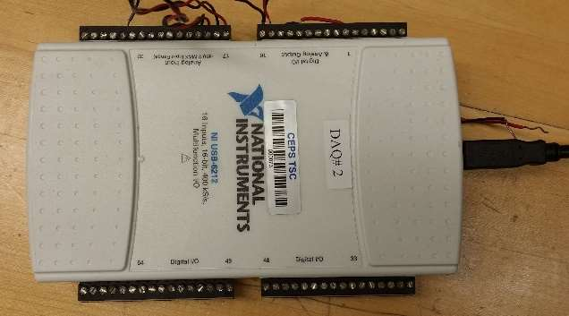

# Results and Discussion

Part 1

THE LINEAR VELOCITY TRANSDUCER

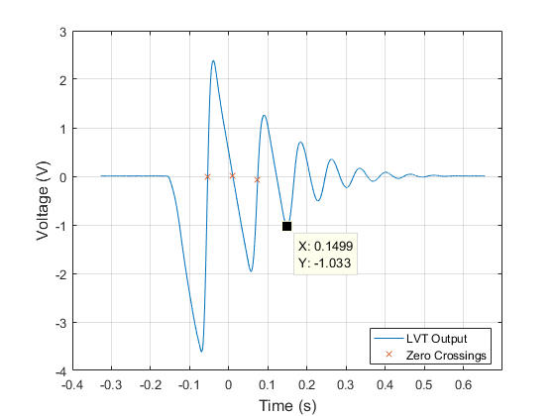

Figure : Plot of LVT measurement voltage vs. time

**The Motion Of Mass:**

During free fall, the slope of the velocity is linear, indicating there is a constant force acting on it in the negative direction – this is the force of gravity. The slope of the velocity measurements are negative, indicating by convention that the mass is falling. During initial impact with the foam, the velocity is still negative but begins to increase towards the positive direction, indicating the foam slows down the mass and slowly accelerates it at constant force (spring force) in the positive, upwards direction. When the velocity measurement crosses zero the first time at the leftmost labeled X point in Figure 1, the mass has reached the bottom of its trajectory inside the foam with maximum elastic potential energy and zero kinetic energy. Therefore, a short while after the X point the mass would bounce off the foam. At that moment, the mass would be travelling in the positive y direction and experience only experience the negative acceleration of gravity.

**The Physical significance of** the first three zero crossings are labeled by X in Figure 1. The first zero crossing is when the mass reached the lowest point inside the foam. The second zero crossing is when the mass reached the highest point after first bounce. The third zero crossing is when the mass reached the lowest point (with respect to each cycle) inside the foam. The first minimum voltage point is when the mass is about to hit the foam at a point where the gravitational potential energy is entirely converted to kinetic energy (maximum speed). The first maximum voltage point is when the mass reached the damped starting position where the undamped net displacement would be zero and velocity would be maximized.

**After three free falls**, the approximate time when the mass stopped bouncing off the foam is 0.15s. After that point, the negative displacement part of the velocity measurement appeared more like a second order damped output.

**Sensitivity of the Instrument:**

The MATLAB Polyfit linear regression function of the initial slope gives -47.251 V/s. With gravity, g = -386 in/sec2:

**Integrated Position and Velocity**

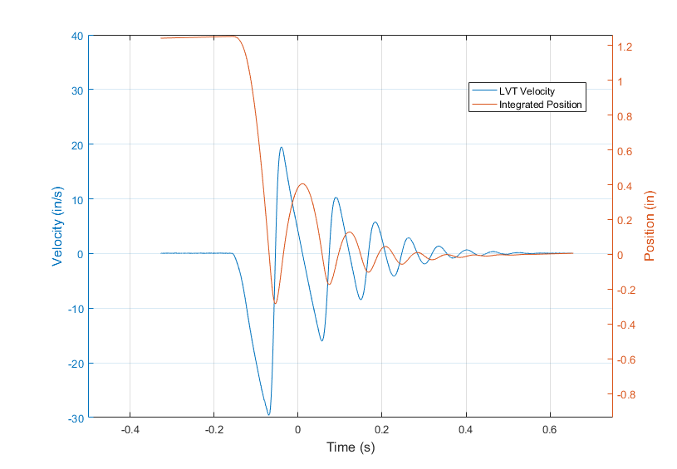

Figure : LVT measurement converted to velocity and integrated to give position

Figure 3, next page, shows the damped foam-mass system response. The circular peaks are used to determine the damping ratio and damped natural frequency. The spring constant is found using the equation: $k=ω_{n}^{2}*m$.

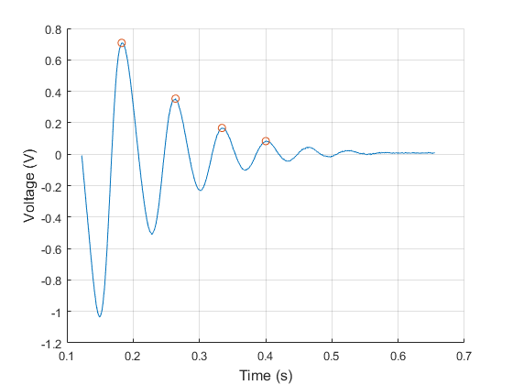

Figure : Damped portion of the foam-mass system

2.1

LVDT CHARACTERISTICS

Figure 1 below shows a plot of coil 1 and coil 2 before amplitude demodulation:

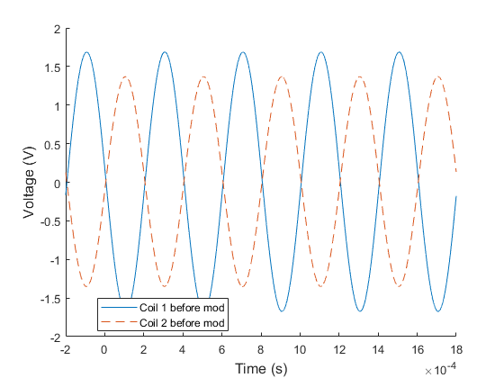

Figure : Coil 1 and coil 2 downward deflection output before demodulation

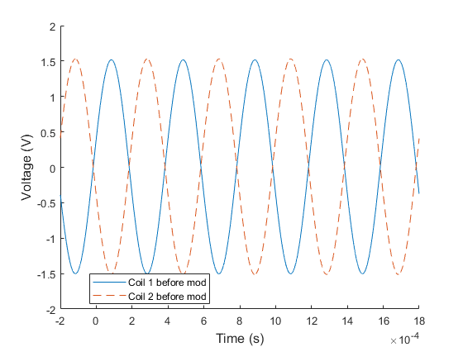

Figure : Coil 1 and coil 2 null output before demodulation

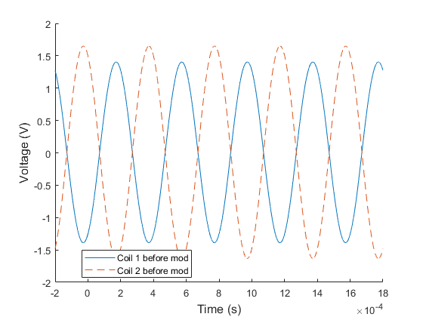

Figure : Coil 1 and coil 2 upward output before demodulation

Figure 1 shows the coil outputs when beam is deflected downwards; Figure 2 shows the outputs when the beam is static (no deflection); and Figure 3 shows the outputs when the beam is deflected upwards. When beam is deflected downwards, coil 1 output has a higher amplitude than coil 2, suggesting the metal core is closer to coil 1 than coil 2, which facilitates higher magnetic flux and induces more current in coil 1’s circuit. Similarly, when the beam is deflected upwards, the core is closer to coil 2, resulting in a higher output amplitude. Conforming to this, when the beam is not deflected, both coils’ outputs have the same amplitude. This is characteristic behavior of an LVDT.

A phase-sensitive demodulator demodulated the modulated coil signals using diode Wheatstone bridges (eliminating negative portions of periodic signals). A modulated signal is one where the output is combined with a carrier wave to raise the signal to the detectable bandwidth range. **Error! Reference source not found.** shows the demodulated result of the coil’s output signals from the LVDT’s excitation signal of 10 V sine wave at 2.5 kHz.

The diodes block currents in the opposite direction. Therefore, demodulation will result in signals all on one side, as shown by the almost-M shaped signals for upwards and downwards deflections. The variations in the deflections as well as the no-deflection (null) state are results of the carrier frequency for the modulated signal.

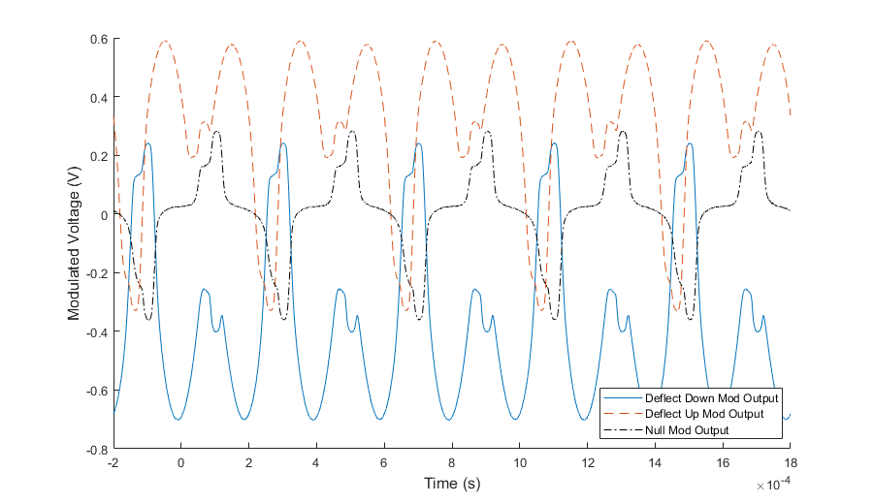

Figure : Amplitude modulated coil outputs at the three deflection conditions

The sensitive nature of the demodulation circuit calls for the need of a low-pass filter to remove the high frequency carrier wave in the output signal. This experiment used an RC circuit with a break frequency of 213 rad/s to act as the filter and the outputs are shown in Figure 5. It can be seen that when deflected upwards the output is positive, downwards is negative, and no deflection has an output of approximately zero.

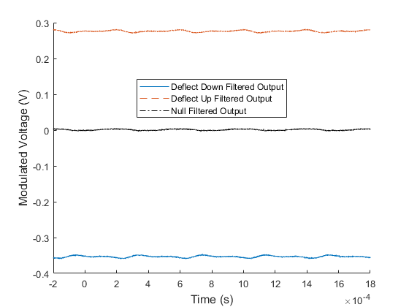

Figure : Demodulated signal after low-pass filter

2.2

Figure 1 and Figure 2 show the output voltage from the LVDT-beam setup at controlled loads, and controlled deflections. Both data are highly linear as shown with the linearly fitted lines. The coefficient of determination, $R^{2}$, value of the linear fits to the two sets of data are 0.9991 and 1.0 respectively. The coefficient equation is: $R^{2}=1-\frac{\sum{{\left(y-y_{fit}\right)}^{2}}}{\sum{{\left(x-\overline{x}\right)}^{2}}}$

The high linearity suggests the slopes can be the sensitivity of the LVDT for loads and displacements. The original data of the two sets are shown in Table 1 and Table 2 below.

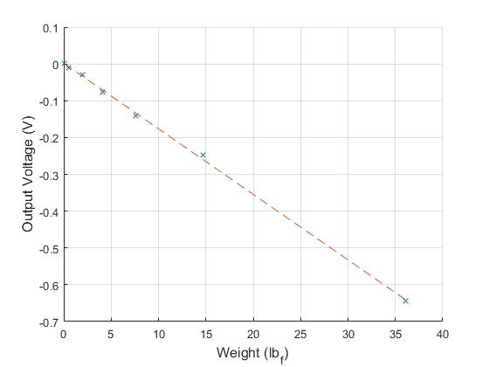

Figure : Controlled Masses versus Output Voltage

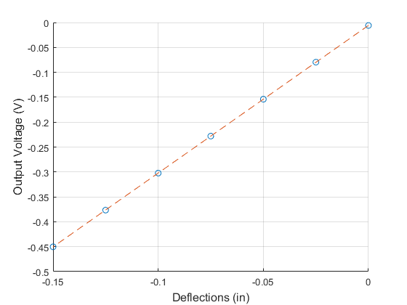

Figure : Controlled Deflections versus Output Voltage

Bucket mass = 7.65 g = 0.0169 lbm on Earth.

Table : Controlled mass loading and output voltage measurements

|  |  |
| --- | --- |
| Masses (lbm) [g]* | Voltage Output (mV) |
| 0 [0 g] | 1.335 |
| 0.0169 [7.65 g] | -10.475 |
| 0.0610 [27.65 g] | -28.59 |
| 0.1271 [57.65 g] | -76.09 |
| 0.2373 [107.65 g] | -140.55 |
| 0.4578 [207.65 g] | -247.43 |
| 1.1192 [507.65 g] | -643.76 |

* all values include the mass of the bucket, values in brackets are original measurements

Pounds mass is converted to pounds force by multiplying by 32.2 ft/s2.

Table : Controlled deflections and output voltage measurements

|  |  |
| --- | --- |
| Deflections (in) | Voltage Output (mV) |
| 0 | -5.9836 |
| -0.025 | -79.61 |
| -0.05 | -153.93 |
| -0.075 | -227.99 |
| -0.1 | -302.31 |
| -0.125 | -376.57 |
| -0.150 | -450.23 |

This linearity is only expected to hold true when the input signal frequency is within the bandwidth of the LVDT.

The spring constant, k has units of force/distance, or load/deflection, can be found after matching the voltage output response of weight to the voltage output response of the deflection.

The weight equivalent deflections are found to be:

|  |  |
| --- | --- |
| Weight (lbf) | Deflection (in) |
| 0 | 35.62 |
| 0.0169 | 14.32 |
| 0.0610 | 7.22 |
| 0.1271 | 3.67 |
| 0.2373 | 1.54 |
| 0.4578 | 0.12 |
| 1.1192 | -0.42 |

Polyfitting this data to a line gives a slope of 9166.5, suggesting the spring constant of the beam to be 166.5 lbf/in. The negative sign indicates weights are equivalent to negative deflections. The data and polyfitted line are shown in Figure 3:

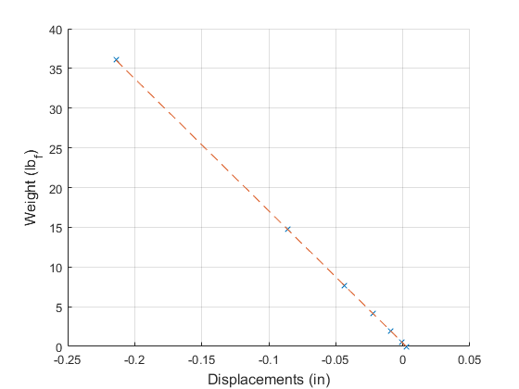

Figure : Weight vs. Deflection of the beam to find spring constant K

The linearity of the data suggests the sensitivity of the LVDT for deflection to be equal to the slope of the voltage versus deflection fit line: 2.9643 V/in.

The damping ratio of the system was found to be .0050. The damped natural frequency was found to be 191.500 rad/s, and the undamped natural frequency (of the first mode of vibration) was found to be 191.533 rad/s. Finally, the effective mass of the system was calculated to be 0.0045 kg



From the bode diagram of Low-pass filter, it can be seen that the LVDT output will only be affected by the filter when the input frequency is greater than approximately 200 rads/sec

2.3

The theoretical bode plot seems like it has a usable bandwidth that reaches a higher range than the experimental. The sensitivity for both is about the same

The core also has a resonant frequency that can add noise to the output signal. This resonant frequency can be an issue while the core is moving or force is applied to it.

Lowering input frequency will increase the sensitivity of the system at the usable bandwidth.

# Conclusions

# References

# Appendices

**StatementOfSharedEffort.pdf**